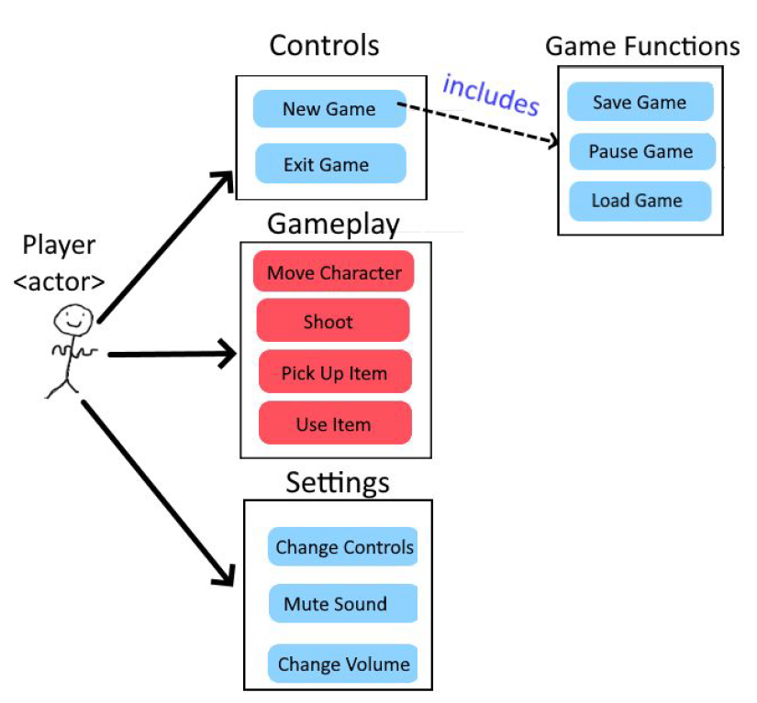

Controls

New Game

Exit Game

Game Functions

Save Game

Pause Game

Load Game

Gameplay

Move Character

Shoot

Pick Up Item

Use Item

Settings

Change Controls

Mute Sound

Change Volume

Player

<actor>

<<includes>>